Locadex Notes and Reminders

Documentation

Help Manual

**Authors:**

Eric Elder (eje8449@sru.edu)

Mike Hamer (smh6273@sru.edu)

Chris Spack (cas1002@sru.edu)

**April 2012**

This document has been created to fulfill the requirements of Dr. Paul Mullin’s 2012 Spring Semester Software Engineering Class (CPSC488) at Slippery Rock University. This document describes the help manual for the Locadex Notes and Reminders Android application.

Table of Contents

Notes__

Jeb bothers me.

Checklists________

Creating a new Checklist

Start creating a new checklist by tapping the in the top right corner of the application. This will prompt the user to add a title and category for the new checklist. Doing so the user may click “Ok” to confirm and create the checklist or “Cancel” to discard the checklist.

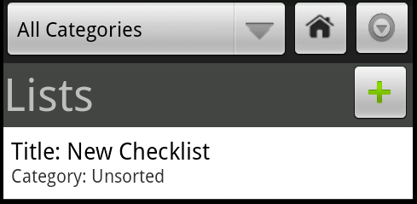

Figure - A new checklist

Editing a Checklist

To edit a previously created checklist, tap and hold on a selected checklist until the following dialog appears:

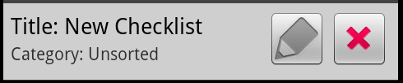

Clicking on the pencil icon will bring up a dialog where you will be prompted to change the checklist’s title. Tapping “Ok” will confirm the edit and “Cancel” will discard the changes.

Deleting a Checklist

Reminders

Reminders, the cancel button works great.

Markers

Finished, too lazy to do this right now.